**“NEXUS SERVICE marketing system’’**

**group members**

**Project Instructor**

**Miss Sana Sheeraz**

AHSAN JAMEEL

M ZAFEER ANSARI

ABU-HURRAIRA KHAN



HOME/NEVIGATION BAR

SCREENSHOT:



CODING SCREENSHOT:

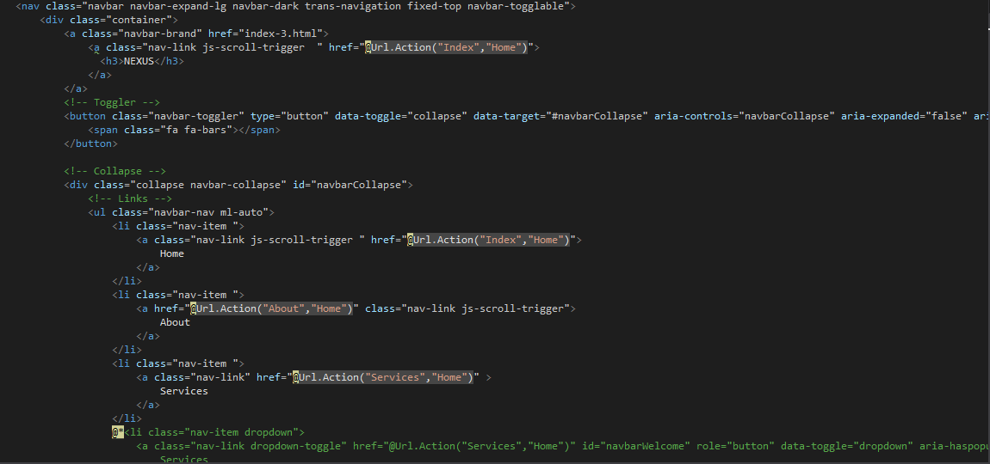About:

SCREENSHOT:



CODING SCREENSHOT:

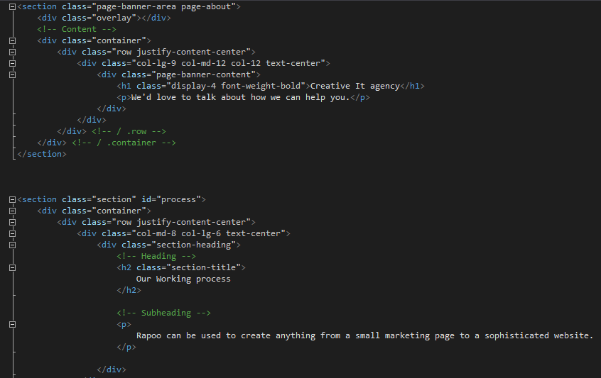

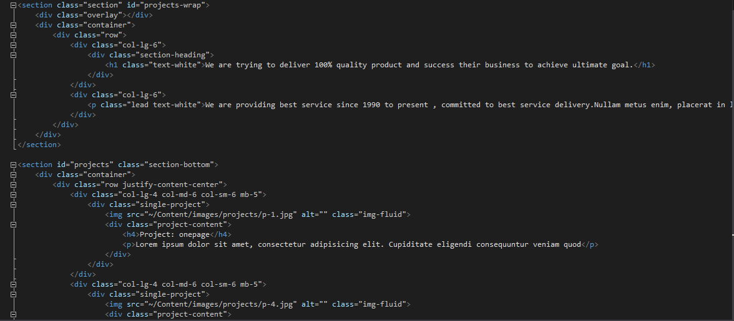

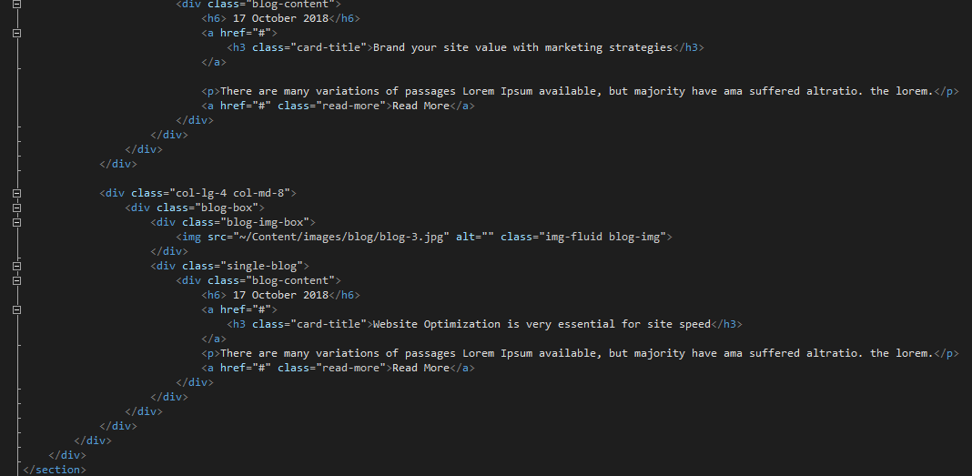

SERVICES

SCREENSHOT:



CODING SCREENSHOT:

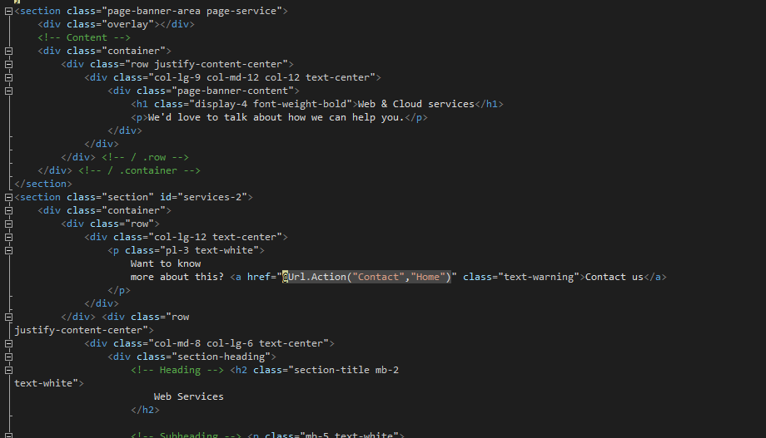

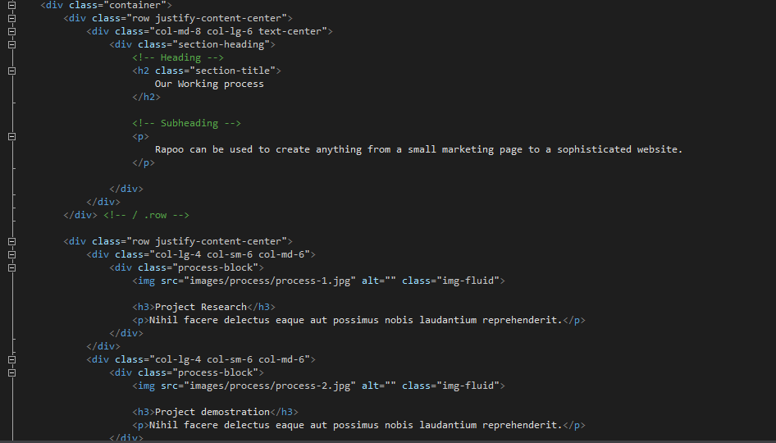

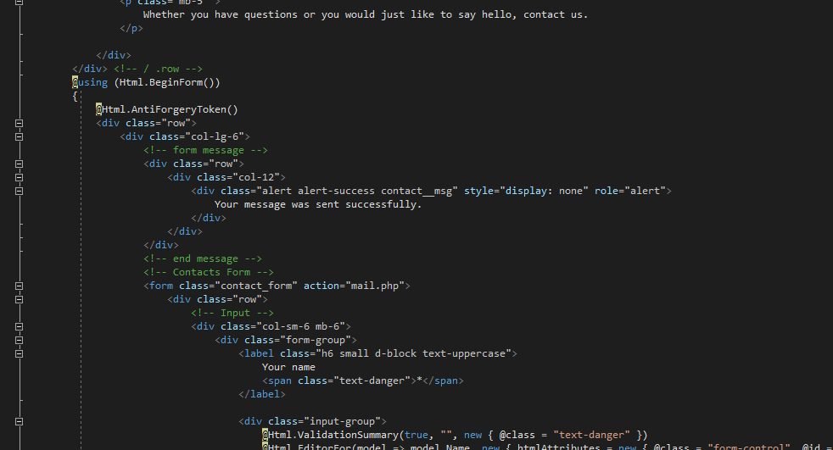

Contact:

SCREENSHOT:



CODING SCREENSHOT:

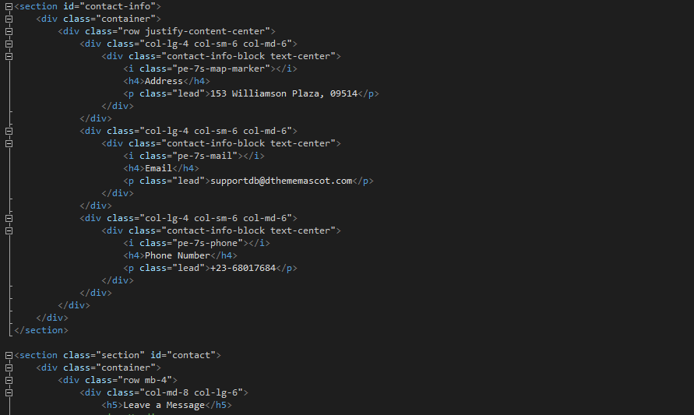



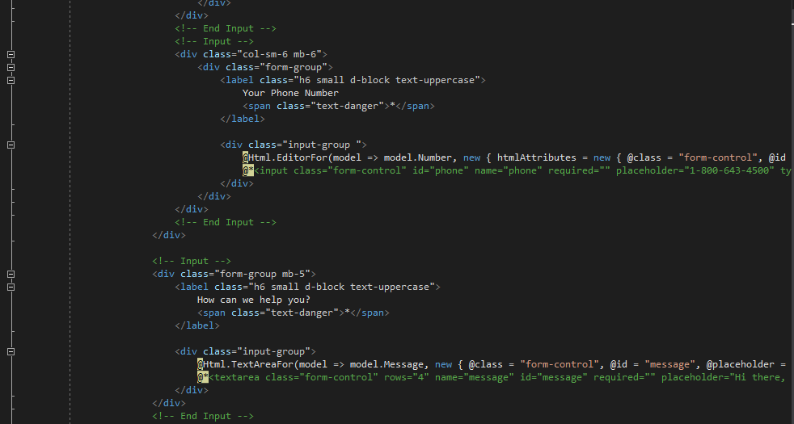

ACCOUNTS

SCREENSHOT:

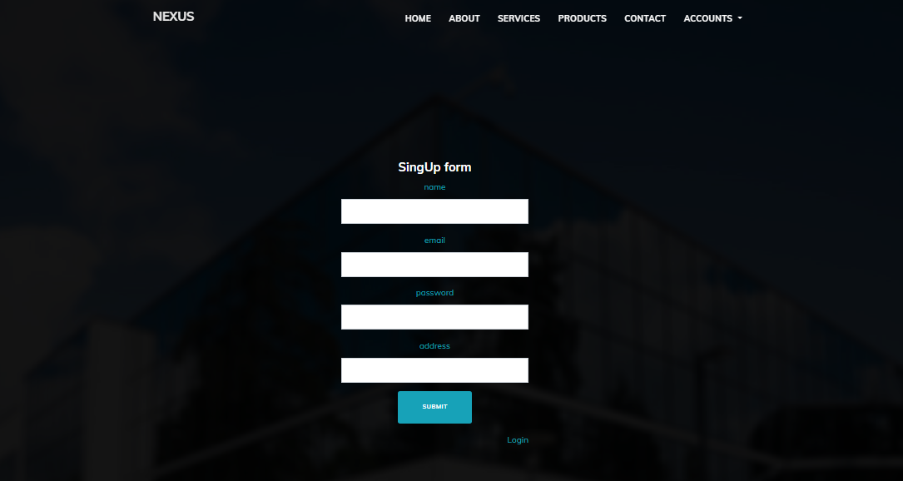

CODING SCREENSHOT:

